Steps for the lab
Download and install NASM from
http://www.osdever.net/downloads/assemblers/nasm-0.98.35-1.i386.rpm
$sudo apt install nasm

Create a first Bootloader that does nothing
create a file firstBootLoader.asm

[BITS 16] ;tell the assembler that its a 16 bit code
[ORG 0x7C00] ;Origin, tell the assembler that where the code will
;be in memory after it is been loaded

JMP $ ;infinite loop

TIMES 510 - ($ - $$) db 0 ;fill the rest of sector with 0
DW 0xAA55 ; add boot signature at the end of bootloader

Explanation:
[BITS 16]: Our code starts with [BITS 16] which is an assembler directive. This will tell assembler that our code is a 16 bit code.
[ORG 0x7C00]: Then we have used [ORG 0x7C00] which tell assembler to assemble the instructions from Origin 0x7C00. BIOS loads bootloader at physical address 0x7C00 hence we have assemble our bootloader starting from that location.
JMP $: JMP at location $ means jumping to the same location. Thus this nothing but an infinite loop. We just want to hang our code here.
TIMES 510 - ($ - $$) db 0: As bootloader is always of length 512 bytes, our code does not fit in this size as its small. We need to use rest of memory and hence we clear it out using TIMES directive. $ stands for start of instruction and $$ stands for start of program. Thus ($ - $$) means length of our code.
DW 0xAA55: This is boot signature. This tells the BIOS that this is a valid bootloader. If bios does not get 0x55 and 0xAA at the end of the bootloader than it will treat bootloader as invalid. Thus we provide this two bytes at the end of our bootloader.

Compile the program
$nasm firstBootLoader.asm -f bin -o boot.bin

Create a floppy image using
dd if=boot.bin bs=512 of=floppy1.img

Attach the floppy image to the Virtual machine and boot. You should see a blank screen

OR

Run using the emulator in UBUNTU

- sudo apt-get install qemu-system-x86_64

- qemu-system-x86_64 -drive file=boot.bin,index=0,media=disk,format=raw

- Create 2nd Bootloader that prints ‘A’ on the screen
we will use BIOS video interrupt int 0x10.
INT 0x10 is a BIOS video interrupt. All the video related calls are made through this interrupt.
To use this interrupt we need to set the values of some register.
AL = ASCII value of character to display
AH = 0x0E ;Teletype mode (This will tell bios that we want to print one character on screen)
BL = Text Attribute (This will be the fore ground and background color
of character to be displayed. 0x07 in our case.)
BH = Page Number (0x00 for most of the cases)

Code saved in secondBootLoader.asm

bits 16
org 0x7c00
boot:
mov si,hello
mov ah, 0x0e
.loop:
lodsb
or al,al
jz halt
int 0x10
jmp .loop
halt:
cli
hlt
hello: db "A",0
times 510 - ($-$$) db 0
dw 0xaa55

Compile the program
nasm secondBootLoader.asm -f bin -o boot2.bin

Run using the emulator

qemu-system-x86_64 -drive file=boot2.bin,index=0,media=disk,format=raw
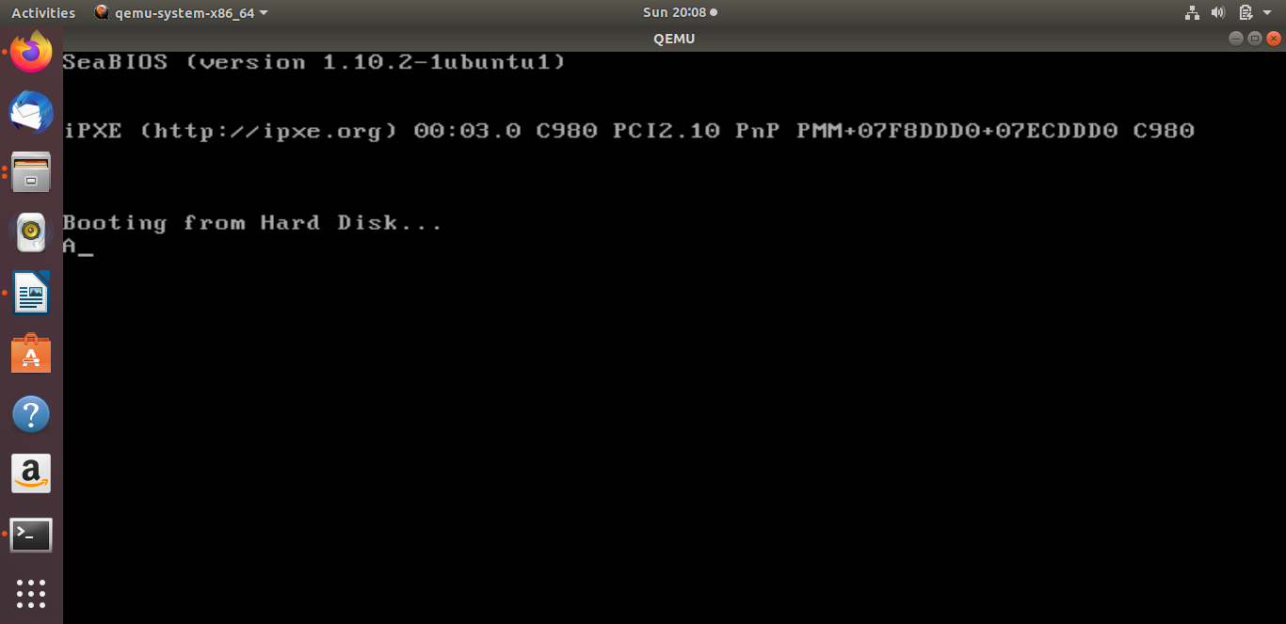
Try this too.

- Code saved in secBootLoader2.asm
[BITS 16] ;Tells the assembler that its a 16 bit code
[ORG 0x7C00] ;Origin, tell the assembler that where the code will
;be in memory after it is been loaded

MOV AL, 65
CALL PrintCharacter
JMP $ ;Infinite loop, hang it here.

PrintCharacter: ;Procedure to print character on screen
;Assume that ASCII value is in register AL
MOV AH, 0x0E ;Tell BIOS that we need to print one charater on screen.
MOV BH, 0x00 ;Page no.
MOV BL, 0x07 ;Text attribute 0x07 is lightgrey font on black background

INT 0x10 ;Call video interrupt
RET ;Return to calling procedure

TIMES 510 - ($ - $$) db 0 ;Fill the rest of sector with 0
DW 0xAA55 ;Add boot signature at the end of bootloader
- Third Bootloader that prints your name say “Shyamala”
Its time to create our final YourName bootloader. We have enough experience now and can code it without wasting a second. So once again start your favorite text editor and start writing following code

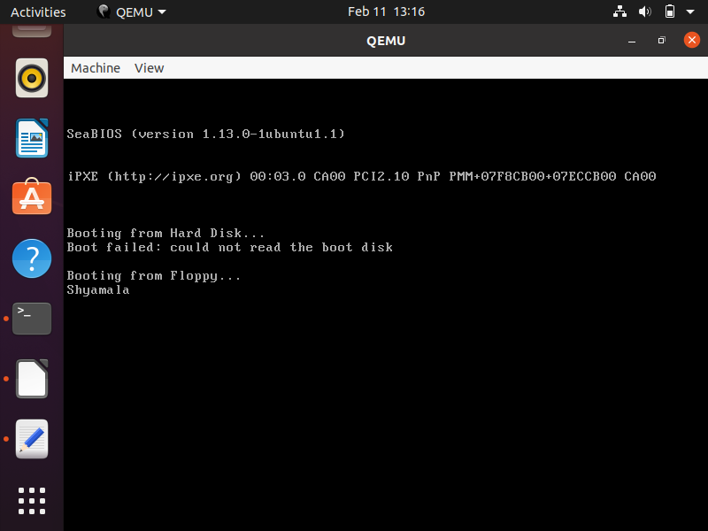
- Boot Loader – Load a kernel (optional)
http://wiki.osdev.org/Bootable_El-Torito_CD_with_GRUB_Legacy
Create a directory structure
mkdir -p isofiles/boot/grub

You now created an isofiles directory in your home folder and a boot/grub sub-folder inside that. We need the stage2 file. It is installed from the grub package. Just copy it:
cp /usr/lib/grub/i386-pc/stage2_eltorito ~/isofiles/boot/grub/

get stage2_eltoritor from and put it in the grub dir
https://sourceforge.net/p/squeaknos/git/ci/bc73aeae09ef3ac8b1a9e708ba07589236b4bb15/tree/boot/iso.template/boot/grub/stage2_eltorito

Install a kernel
Get a kernel of your own choosing and copy it to wherever you like inside the isofiles folder. Preferably it should be placed in the boot sub-folder. Now create a menu.lst file. This file controls what menu entries GRUB should provide and how the kernels are booted. It must be placed in the GRUB folder boot/grub and contain something like this:

Copy a compiled kernel from your machine – it will not work but explains how
default 0
#timeout 30

#title Boot from hard disk
#chainloader (hd0)+1

title My kernel
kernel /boot/vmlinuz-4.8.15-300.fc25.x86_64 # Edit it to the filename of your kernel.

Create the .iso image
In the following I use the command genisoimage, but you can change it to mkisofs if that is what its called on your system. Open a command prompt/terminal and go to where the isofiles folder is located. It is your home directory on Ubuntu. Issue the command:
genisoimage -R -b boot/grub/stage2_eltorito -no-emul-boot -boot-load-size 4 -boot-info-table -o bootable.iso isofiles

- Load the ISO into virtual machine and boot.

References
1. http://3zanders.co.uk/2017/10/13/writing-a-bootloader/
2. http://mikeos.sourceforge.net/write-your-own-os.html
3.https://blog.ghaiklor.com/2017/10/21/how-to-implement-your-own-hello-world-boot-loader/

